C768 Technical Communication

Task 1

2019

Table of Contents

Internal Communication Artifact1

**Procedural Fact Sheet**2

**Writing Process Analysis**3

Audience Analysis4



|  |
| --- |
| 253-555-1111 |
| Smart Phone |
| Dyates7@wgu.edu |
| Envelope |
| Damian J. Yates |
| User |

http://www.damianjyates.com

Executive Staff

2325 SomeStreet, Somecity, WA 98372

Dear **Executive Staff**,

We have settled on a phone solution to replace our current phone system. Why the need to change phone systems you ask? Our existing system is well past its end of life and is no longer supported by its manufacturer. Additionally, with us moving a large majority of our operations to the cloud to foster increased work productivity, having a static phone system is counter productive to ensure that communications between staff and customers are as fluid as we expect our staff to be. The phone system we will be moving to is [Ring Central](https://www.ringcentral.com/). This platform will become our companies unified communications system incorporating telephony, instant messaging, meetings and video conferencing. Making this change will improve productivity 25% to 30% by allowing our employees to access real-time communications regardless of their location. The ROI on the implementation of this solution will be prevalent when factoring in the cost of implementing each portion of the communications system individually.

People have a hard time acclimating to new technologies, who do you expect our staff to learn and accept this new software? Good question, with the implementation of this new system, Ring Central will provide several learning sessions for our staff. In addition to these sessions, Ring Central offers online support and has a spectacular library of how to documents available for review.

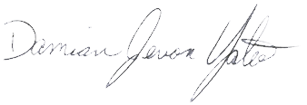With the introduction of this new technology, Damian J. Yates, LLC will improve upon its capabilities and productivity thus allow us to provide that grade A support to our customers and internal staff. I ask that if you have any questions regarding this deployment that you submit them via email to ensure that all queries and concerns are addressed.

Warm regards,

Damian J. Yates

Owner

RC Phone Install Notes



Ring Central will be replacing our Phones, Meeting, Collaboration, Instant Messaging and Faxing throughout the organization. New Phones will need to be delivered to each new workstation. Users will be informed that technicians will be by to install and set up the phones this week.

Once you arrive at the desk you will need to do the following:

1. Unbox the product.
2. Plug cord in to headset 1 and the other end into port A on phone.
3. Take ethernet cable plugged into rear of computer 2, see example Z, and plug it into port B of phone.
4. Take patch cable from the box the phone came in and place one end in computer port 2 and the other in phone port C.

At this point the phone should be powered on and displaying the users name. Verify internet connectivity at the PC and dial tone at the phone. If either of these are absent, open a trouble ticket with the network team

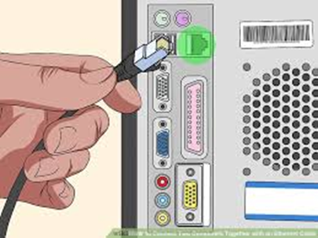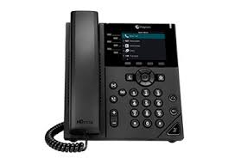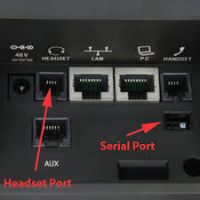

Introducing the Polycom VVX250

Comes preconfigured with users information!  
Easy Installation!  
Just Plug and Play!  
No power required!

1

A

2

Z

B

C